Numeration
# Source: AI Source: Provided by: [Data Path: Persons Table -> ID Column: 1, Name_En Column: Motasem Essam] -> From: [ChatGPT] on [7/11/2026]
Numeration is the system of representing, reading, writing, and naming numbers using digits and place values. It provides a standardized way to express numbers of any size and understand their values.
Numeration is one of the fundamental concepts in mathematics and forms the basis for counting, arithmetic operations, measurement, and many other mathematical topics.

Definition:
# Source: AI Source: Provided by: [Data Path: Persons Table -> ID Column: 1, Name_En Column: Motasem Essam] -> From: [ChatGPT] on [7/11/2026]
Numeration is the method of expressing numbers using a set of symbols (digits) according to a place-value system.
In the decimal (base-10) numeration system, ten digits are used:
0,1,2,3,4,5,6,7,8,9
These digits can be combined to represent any whole number.

Decimal Numeration System
# Source: AI Source: Provided by: [Data Path: Persons Table -> ID Column: 1, Name_En Column: Motasem Essam] -> From: [ChatGPT] on [7/11/2026]
The decimal numeration system is based on:
- 10 digits (0–9)
- Place value
- Powers of 10
Each position in a number has a value that is 10 times the value of the position to its right.
Example:
5,482

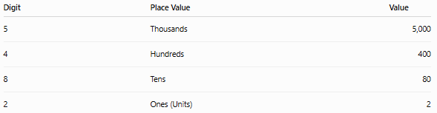
Digit | Place Value | Value
5 | Thousands | 5,000
4 | Hundreds | 400
8 | Tens | 80
2 | Ones (Units) | 2
Therefore,
5,482=5×1000+4×100+8×10+2×1

Components of Numeration
# Source: AI Source: Provided by: [Data Path: Persons Table -> ID Column: 1, Name_En Column: Motasem Essam] -> From: [ChatGPT] on [7/11/2026]
A numeration system consists of:

1. Digits
# Source: AI Source: Provided by: [Data Path: Persons Table -> ID Column: 1, Name_En Column: Motasem Essam] -> From: [ChatGPT] on [7/11/2026]
The basic symbols used to write numbers.
Example:
0,1,2,3,4,5,6,7,8,9

2. Place Value
# Source: AI Source: Provided by: [Data Path: Persons Table -> ID Column: 1, Name_En Column: Motasem Essam] -> From: [ChatGPT] on [7/11/2026]
Place value is the value of a digit based on its position in a number. The same digit can have different values depending on where it appears. Place value is one of the most important concepts in arithmetic because it forms the basis of reading, writing, comparing, and performing operations on numbers.
- For example, in the number 5,482, the digit 5 represents 5 thousand, while the digit 2 represents 2 ones.

Definition
# Source: AI Source: Provided by: [Data Path: Persons Table -> ID Column: 1, Name_En Column: Motasem Essam] -> From: [ChatGPT] on [7/11/2026]
Place value is the value assigned to a digit according to its position within a number.
Mathematically:
Place Value= Digit × Value of its Position

Importance of Place Value
# Source: AI Source: Provided by: [Data Path: Persons Table -> ID Column: 1, Name_En Column: Motasem Essam] -> From: [ChatGPT] on [7/11/2026]
Place value helps us:
- Read and write large numbers.
- Compare numbers.
- Order numbers.
- Perform arithmetic operations.
- Write numbers in expanded form.
Understand the decimal number system.

Examples
# Source: AI Source: Provided by: [Data Path: Persons Table -> ID Column: 1, Name_En Column: Motasem Essam] -> From: [ChatGPT] on [7/11/2026]
○ Example 1
Consider the number:
4,583
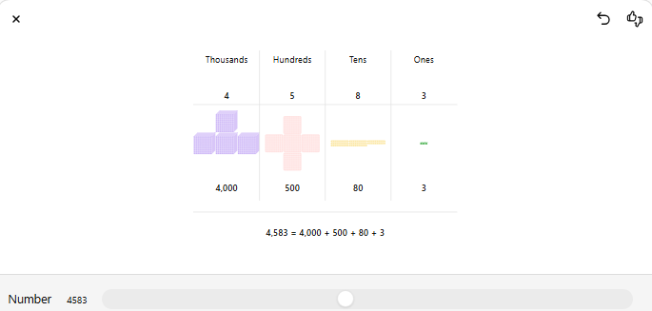
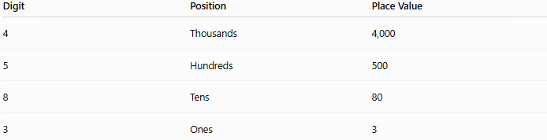
Digit | Position | Place Value
4 | Thousands | 4,000
5 | Hundreds | 500
8 | Tens | 80
3 | Ones | 3
Expanded form:
4,583 = 4,000 + 500 + 80 + 3

○ Example 2
Number:
72,914
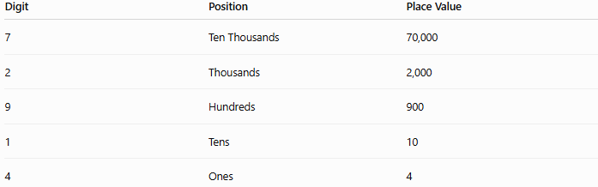
Digit | Position | Place Value
7 | Ten Thousands | 70,000
2 | Thousands | 2,000
9 | Hundreds | 900
1 | Tens | 10
4 | Ones | 4
Expanded form:
72,914 = 70,000 + 2,000 + 900 + 10 + 4

○ Example 3
Number:
305
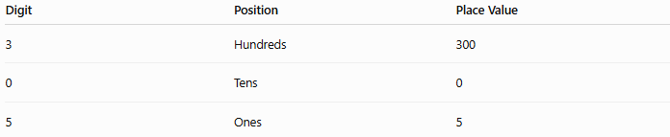
Digit | Position | Place Value
3 | Hundreds | 300
0 | Tens | 0
5 | Ones | 5
Expanded form:
305 = 300 + 0 + 5

○ Illustration
In the number:
6,421
- 6 means 6 thousands = 6,000
- 4 means 4 hundreds = 400
- 2 means 2 tens = 20
- 1 means 1 one = 1

Place Value Chart
# Source: AI Source: Provided by: [Data Path: Persons Table -> ID Column: 1, Name_En Column: Motasem Essam] -> From: [ChatGPT] on [7/11/2026]
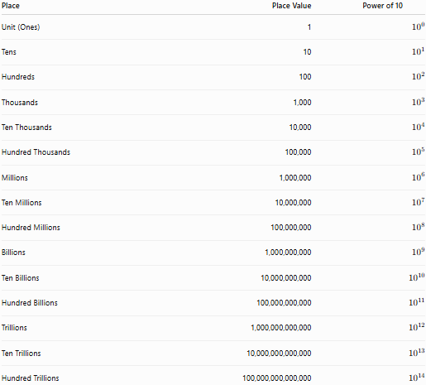
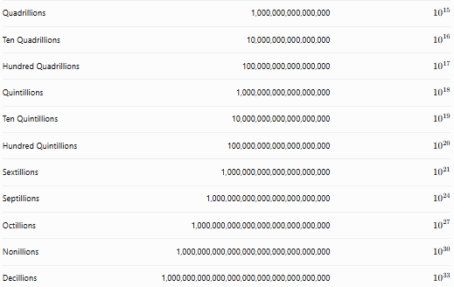
Place | Place Value | Power of 10
Unit (Ones) | 1 | (10^0)
Tens | 10 | (10^1)
Hundreds | 100 | (10^2)
Thousands | 1,000 | (10^3)
Ten Thousands | 10,000 | (10^4)
Hundred Thousands | 100,000 | (10^5)
Millions | 1,000,000 | (10^6)
Ten Millions | 10,000,000 | (10^7)
Hundred Millions | 100,000,000 | (10^8)
Billions | 1,000,000,000 | (10^9)
Ten Billions | 10,000,000,000 | (10^{10})
Hundred Billions | 100,000,000,000 | (10^{11})
Trillions | 1,000,000,000,000 | (10^{12})
Ten Trillions | 10,000,000,000,000 | (10^{13})
Hundred Trillions | 100,000,000,000,000 | (10^{14})
Quadrillions | 1,000,000,000,000,000 | (10^{15})
Ten Quadrillions | 10,000,000,000,000,000 | (10^{16})
Hundred Quadrillions | 100,000,000,000,000,000 | (10^{17})
Quintillions | 1,000,000,000,000,000,000 | (10^{18})
Ten Quintillions | 10,000,000,000,000,000,000 | (10^{19})
Hundred Quintillions | 100,000,000,000,000,000,000 | (10^{20})
Sextillions | 1,000,000,000,000,000,000,000 | (10^{21})
Septillions | 1,000,000,000,000,000,000,000,000 | (10^{24})
Octillions | 1,000,000,000,000,000,000,000,000,000 | (10^{27})
Nonillions | 1,000,000,000,000,000,000,000,000,000,000 | (10^{30})
Decillions | 1,000,000,000,000,000,000,000,000,000,000,000 | (10^{33})

Decimal Place Value Chart
# Source: AI Source: Provided by: [Data Path: Persons Table -> ID Column: 1, Name_En Column: Motasem Essam] -> From: [ChatGPT] on [7/11/2026]
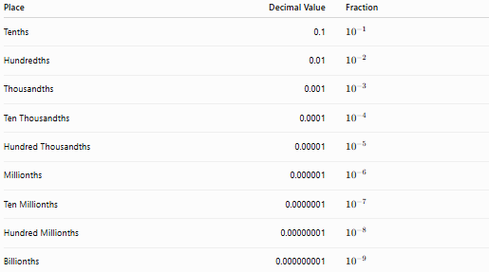
Place | Decimal Value | Fraction
Tenths | 0.1 | (10^{-1})
Hundredths | 0.01 | (10^{-2})
Thousandths | 0.001 | (10^{-3})
Ten Thousandths | 0.0001 | (10^{-4})
Hundred Thousandths | 0.00001 | (10^{-5})
Millionths | 0.000001 | (10^{-6})
Ten Millionths | 0.0000001 | (10^{-7})
Hundred Millionths | 0.00000001 | (10^{-8})
Billionths | 0.000000001 | (10^{-9})

Complete Place Value Chart
# Source: AI Source: Provided by: [Data Path: Persons Table -> ID Column: 1, Name_En Column: Motasem Essam] -> From: [ChatGPT] on [7/11/2026]
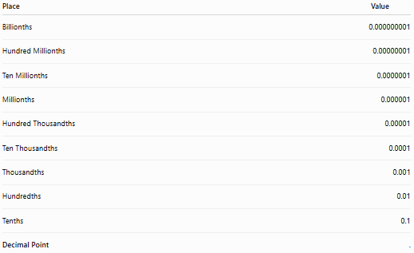
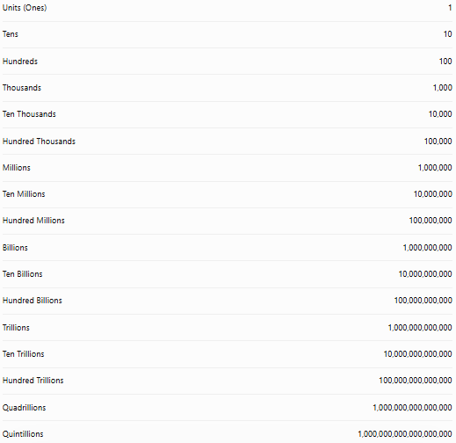
Place | Value
Billionths | 0.000000001
Hundred Millionths | 0.00000001
Ten Millionths | 0.0000001
Millionths | 0.000001
Hundred Thousandths | 0.00001
Ten Thousandths | 0.0001
Thousandths | 0.001
Hundredths | 0.01
Tenths | 0.1
Decimal Point | .
Units (Ones) | 1
Tens | 10
Hundreds | 100
Thousands | 1,000
Ten Thousands | 10,000
Hundred Thousands | 100,000
Millions | 1,000,000
Ten Millions | 10,000,000
Hundred Millions | 100,000,000
Billions | 1,000,000,000
Ten Billions | 10,000,000,000
Hundred Billions | 100,000,000,000
Trillions | 1,000,000,000,000
Ten Trillions | 10,000,000,000,000
Hundred Trillions | 100,000,000,000,000
Quadrillions | 1,000,000,000,000,000
Quintillions | 1,000,000,000,000,000,000

Period (Place Value)
# Source: AI Source: Provided by: [Data Path: Persons Table -> ID Column: 1, Name_En Column: Motasem Essam] -> From: [ChatGPT] on [7/11/2026]
A period in the decimal place value system is a group of three consecutive place values. Periods are used to organize large numbers, making them easier to read, write, and understand.
Numbers are separated into periods by commas (or spaces in some countries). Each period contains three places:
- Units (Ones) place
- Tens place
- Hundreds place

Definition:
# Source: AI Source: Provided by: [Data Path: Persons Table -> ID Column: 1, Name_En Column: Motasem Essam] -> From: [ChatGPT] on [7/11/2026]
A period is a group of three adjacent place values in the decimal place value system. Each period represents a different magnitude of a number and is separated from the next period by a comma (or another grouping separator).

Period Place Value Chart
# Source: AI Source: Provided by: [Data Path: Persons Table -> ID Column: 1, Name_En Column: Motasem Essam] -> From: [ChatGPT] on [7/11/2026]
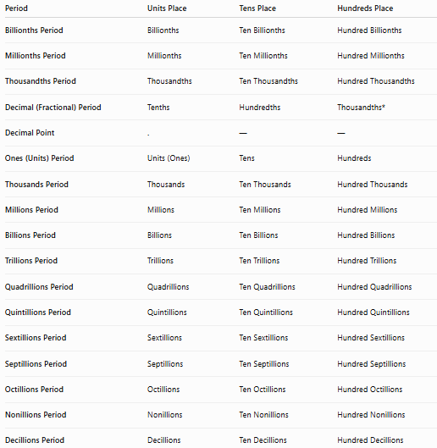
Period | Units Place | Tens Place | Hundreds Place
Billionths Period | Billionths | Ten Billionths | Hundred Billionths
Millionths Period | Millionths | Ten Millionths | Hundred Millionths
Thousandths Period | Thousandths | Ten Thousandths | Hundred Thousandths
Decimal (Fractional) Period | Tenths | Hundredths | Thousandths*
Decimal Point | . | — | —
Ones (Units) Period | Units (Ones) | Tens | Hundreds
Thousands Period | Thousands | Ten Thousands | Hundred Thousands
Millions Period | Millions | Ten Millions | Hundred Millions
Billions Period | Billions | Ten Billions | Hundred Billions
Trillions Period | Trillions | Ten Trillions | Hundred Trillions
Quadrillions Period | Quadrillions | Ten Quadrillions | Hundred Quadrillions
Quintillions Period | Quintillions | Ten Quintillions | Hundred Quintillions
Sextillions Period | Sextillions | Ten Sextillions | Hundred Sextillions
Septillions Period | Septillions | Ten Septillions | Hundred Septillions
Octillions Period | Octillions | Ten Octillions | Hundred Octillions
Nonillions Period | Nonillions | Ten Nonillions | Hundred Nonillions
Decillions Period | Decillions | Ten Decillions | Hundred Decillions

Why Periods Are Used
# Source: AI Source: Provided by: [Data Path: Persons Table -> ID Column: 1, Name_En Column: Motasem Essam] -> From: [ChatGPT] on [7/11/2026]
Periods help us:
- Read very large numbers more easily.
- Identify place values quickly.
- Write numbers correctly.
- Perform arithmetic operations.
- Avoid mistakes when reading long numbers.

Real-Life Examples
# Source: AI Source: Provided by: [Data Path: Persons Table -> ID Column: 1, Name_En Column: Motasem Essam] -> From: [ChatGPT] on [7/11/2026]
1. Population
8,215,643
- 8 → Millions Period
- 215 → Thousands Period
- 643 → Ones Period

2. Money
1,250,000
- 1 → Millions Period
- 250 → Thousands Period
- 000 → Ones Period

3. Scientific Measurements
0.123456789
- 123 → Thousandths Period
- 456 → Millionths Period
- 789 → Billionths Period

Period vs. Place Value
# Source: AI Source: Provided by: [Data Path: Persons Table -> ID Column: 1, Name_En Column: Motasem Essam] -> From: [ChatGPT] on [7/11/2026]
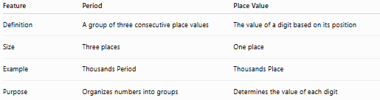
Feature | Period | Place Value
Definition | A group of three consecutive place values | The value of a digit based on its position
Size | Three places | One place
Example | Thousands Period | Thousands Place
Purpose | Organizes numbers into groups | Determines the value of each digit

Illustration
# Source: AI Source: Provided by: [Data Path: Persons Table -> ID Column: 1, Name_En Column: Motasem Essam] -> From: [ChatGPT] on [7/11/2026]
Number:
5,483,926,741
Billions | Millions | Thousands | Ones
5 | 483 | 926 | 741
Each colored block (or comma-separated group) is a period, while each individual digit occupies its own place value.

Conclusion
# Source: AI Source: Provided by: [Data Path: Persons Table -> ID Column: 1, Name_En Column: Motasem Essam] -> From: [ChatGPT] on [7/11/2026]
A period is a group of three consecutive place values in the decimal place value system. Periods organize both whole numbers and decimal fractions, making large and small numbers easier to read, write, and interpret.
Memory Tip
Think of a period as a 3-digit block.
- Place Value = the position of one digit (e.g., Tens, Hundreds).
- Period = a group of three place values (e.g., Thousands Period, Millions Period).

Place Value Examples in Real Life
# Source: AI Source: Provided by: [Data Path: Persons Table -> ID Column: 1, Name_En Column: Motasem Essam] -> From: [ChatGPT] on [7/11/2026]
1. Money
In $1,250:
- 1 represents 1 thousand dollars
- 2 represents 2 hundreds
- 5 represents 5 tens
- 0 represents 0 ones

2. Population
A city population of 3,482,615:
- 3 million
- 4 hundred thousand
- 8 ten thousand
- 2 thousand
- 6 hundred
- 1 ten
- 5 ones

3. Distance
A road length of 12,450 meters:
- 1 ten thousand
- 2 thousands
- 4 hundreds
- 5 tens

4. Banking
A balance of 25,360:
Each digit has a different place value that determines the total amount.

5. Scientific Data
Measurements and calculations use place value to represent large and small numbers accurately.

Applications
# Source: AI Source: Provided by: [Data Path: Persons Table -> ID Column: 1, Name_En Column: Motasem Essam] -> From: [ChatGPT] on [7/11/2026]
Place value is used in:
- Arithmetic
- Algebra
- Measurement
- Finance
- Accounting
- Computer Science
- Statistics
- Everyday calculations

3. Face Value
# Source: AI Source: Provided by: [Data Path: Persons Table -> ID Column: 1, Name_En Column: Motasem Essam] -> From: [ChatGPT] on [7/11/2026]
The face value of a digit is the digit itself, regardless of its position.
Example:
In
8,542
The face value of 5 is simply:
5

4. Expanded Form
# Source: AI Source: Provided by: [Data Path: Persons Table -> ID Column: 1, Name_En Column: Motasem Essam] -> From: [ChatGPT] on [7/11/2026]
A number can be written as the sum of the values of its digits.
Example:
9,746
Expanded form:
9,000+700+40+6

5. Standard Form
# Source: AI Source: Provided by: [Data Path: Persons Table -> ID Column: 1, Name_En Column: Motasem Essam] -> From: [ChatGPT] on [7/11/2026]
Writing a number using digits.
Example:
Nine thousand seven hundred forty-six
↓
9,746

6. Word Form
# Source: AI Source: Provided by: [Data Path: Persons Table -> ID Column: 1, Name_En Column: Motasem Essam] -> From: [ChatGPT] on [7/11/2026]
Writing a number using words.
Example:
12,508
Word form:
Twelve thousand five hundred eight

Face Value vs. Place Value
# Source: AI Source: Provided by: [Data Path: Persons Table -> ID Column: 1, Name_En Column: Motasem Essam] -> From: [ChatGPT] on [7/11/2026]
The face value of a digit is the digit itself, regardless of its position.
The place value depends on where the digit is located.
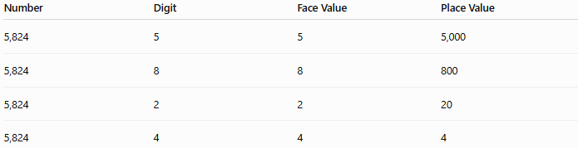
Number | Digit | Face Value | Place Value
5,824 | 5 | 5 | 5,000
5,824 | 8 | 8 | 800
5,824 | 2 | 2 | 20
5,824 | 4 | 4 | 4

Reading Numbers
# Source: AI Source: Provided by: [Data Path: Persons Table -> ID Column: 1, Name_En Column: Motasem Essam] -> From: [ChatGPT] on [7/11/2026]
Numbers are read from left to right according to their periods and place values.
Example:
4,205,817
Read as:
Four million two hundred five thousand eight hundred seventeen

Writing Numbers
# Source: AI Source: Provided by: [Data Path: Persons Table -> ID Column: 1, Name_En Column: Motasem Essam] -> From: [ChatGPT] on [7/11/2026]
Numbers may be written in:
Standard Form
35,642

Word Form
# Source: AI Source: Provided by: [Data Path: Persons Table -> ID Column: 1, Name_En Column: Motasem Essam] -> From: [ChatGPT] on [7/11/2026]
Thirty-five thousand six hundred forty-two

Expanded Form
# Source: AI Source: Provided by: [Data Path: Persons Table -> ID Column: 1, Name_En Column: Motasem Essam] -> From: [ChatGPT] on [7/11/2026]
30,000+5,000+600+40+2

Examples
# Source: AI Source: Provided by: [Data Path: Persons Table -> ID Column: 1, Name_En Column: Motasem Essam] -> From: [ChatGPT] on [7/11/2026]
Example 1
Write the expanded form of:
6,318
Solution:
6,000+300+10+8

Example 2
Write in word form:
45,207
Solution:
Forty-five thousand two hundred seven

Example 3
Write in standard form:
Nine hundred eighty-three thousand twelve
Solution:
983,012

Example 4
Find the place value of 7 in
572,914
Solution:
The digit 7 is in the ten-thousands place.
Its value is:
70,000

Real-Life Applications
# Source: AI Source: Provided by: [Data Path: Persons Table -> ID Column: 1, Name_En Column: Motasem Essam] -> From: [ChatGPT] on [7/11/2026]
Numeration is used in:
- Counting objects
- Reading prices
- Banking and finance
- Measuring distances
- Recording population
- Scientific calculations
- Computer programming
- Statistics
- Engineering

Numeration vs. Number
# Source: AI Source: Provided by: [Data Path: Persons Table -> ID Column: 1, Name_En Column: Motasem Essam] -> From: [ChatGPT] on [7/11/2026]
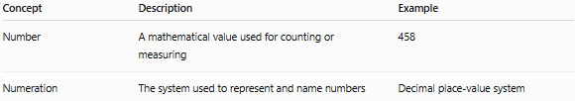
Concept | Description | Example
Number | A mathematical value used for counting or measuring | 458
Numeration | The system used to represent and name numbers | Decimal place-value system

Key Points
# Source: AI Source: Provided by: [Data Path: Persons Table -> ID Column: 1, Name_En Column: Motasem Essam] -> From: [ChatGPT] on [7/11/2026]
- Numeration is the system used to represent numbers.
- The decimal numeration system uses 10 digits (0–9).
- Each digit has a face value and a place value.
- The value of a digit depends on its position.
- Numbers can be written in standard, word, and expanded forms.
- Place values increase by a factor of 10 from right to left.

Conclusion
# Source: AI Source: Provided by: [Data Path: Persons Table -> ID Column: 1, Name_En Column: Motasem Essam] -> From: [ChatGPT] on [7/11/2026]
Numeration is the mathematical system for representing, reading, writing, and interpreting numbers using digits and place values. The decimal numeration system, based on ten digits and powers of ten, enables us to express numbers of any size efficiently. A solid understanding of numeration is essential for arithmetic, algebra, measurement, finance, science, and everyday problem-solving.

